**WIA2005 Algorithm Design &Analysis**

**Semester 2, 2016/17**

**Lab 10 : Dynamic Programming**

1. You are required to implement a **Memoized Fibonacci** method that deals with big integer. Use the following code to run the memorize Fibonacci.

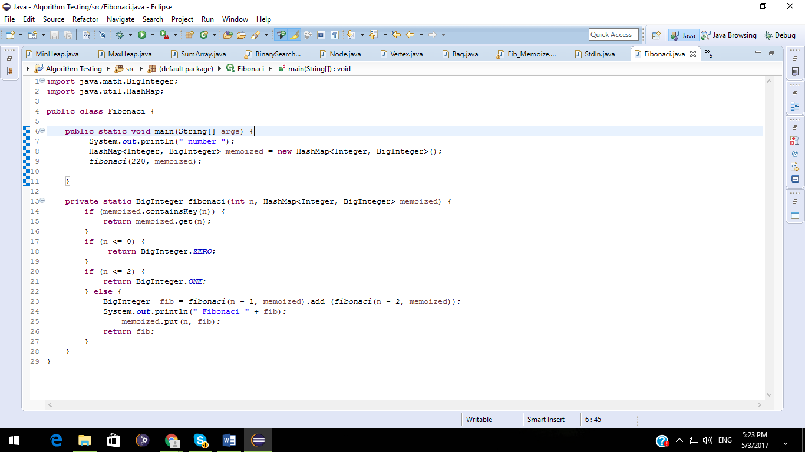

Try to time the time taken to compute Fibonaci of a big number such as the following:

* Fibonaci(220)
* Fibonaci (500)
* Fibonaci(1000)

Use Systems.currentTimeMillis() to capture the time taken for to computer Fibonaci.

1. Implement the tabular form to computer Fibonaci numbers.